

Patient Experience Strategic Plan 2023 – 2028

Patient experience means how receiving care or treatment feels for the patient, their family and carers. Each experience is unique to the individual.

NHS Lothian is committed to improving our services by listening to our users.
This may mean when things go right or wrong. We will do this by:


e

We will ask What Matters to You? This means our staff can work with you to make sure your care supports you to live a good life.



We will encourage you to tell us about your experience of care with NHS Lothian, so we can learn and change.


We will listen to your complaints if something goes wrong with your care. We will investigate and provide you with an answer.

NHS Lothian Patient Experience Aims


People receive treatment in a comfortable, caring and safe environment.



Treatment is delivered in a calm and reassuring way.



People have information to make choices, to feel confident and in control.



People are spoken with and listened to as an equal.

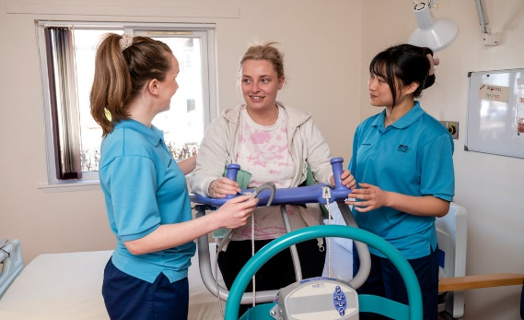

People are treated with honesty, respect and dignity.

